WCU Golden Ram Invitational
Saturday, April 9th, 2022
(as of 3/31/2022)
Teams as of 3/31: WCU, Chestnut Hill, Staten Island, Gwynedd-Mercy, Delaware Valley, Millersville, Lincoln, CC Of Philadelphia, CCBC Cantonsville, Goldey-Beacom, Swarthmore, Wilmington

ENTRIES All entries will be done via DirectAthletics.
- Entry Deadline is Wednesday, April 6th,2022 at 9:59 PM.
      - No additions/changes after the deadline—only scratches please!
      - Entries are unlimited in all track & field events and all relays.

ENTRY FEE $350 per team (men & women are separate teams) or $25 per athlete. Please make checks payable to “SSI #276” and send to Joan Rimkis at WCU Athletics, Sturzebecker Room 220, West Chester PA 19383.

FACILITIES The Farrell Stadium Outdoor Track is an eight-lane Mondo surface
1⁄4” pyramid spikes ONLY.
Starting blocks will be provided.
All jumping events will be contested on Mondo surface inside stadium.
Shot Put will take place inside Farrell stadium.
Discus and hammer are contested adjacent to our softball stadium on the opposite side of the athletic building
Javelin will be thrown off of a grass runway.
Shower facilities will be available in the Sturzebecker Health Science Center adjacent to Farrell Stadium. Athletes must provide their own locks and towels.
Horizontal jumps & throws will be three jumps/throws, then top eight to finals.
Implement weigh-in will take place for marks that reach the NCAA Provisional standard.
Starting Heights will be determined as we get closer to the meet. However we will use progressions that get to the PSAC conference qualifying heights: W HJ (1.58), M HJ (1.85), W PV (3.25), M PV (4.25).

PARKING There is sufficient parking for cars, vans, and buses in the lots in front of
and below the stadium.
Full venue map on next page
INFO Melissa Ferry – Meet Director/ Director of XC/TF
mferry@wcupa.edu; 703-965-1893
Andy Huber – Officials Director
ahuber@wcupa.edu
Timing: Colin Leak, Mark Lacancia
Athletic Training: Lea Blackburn
AT Will be available adjacent to the track near the finish line.

Directions / Map
From US 202: Come High Street to ROSEDALE Avenue through our campus.
(GPS may try to take you down ‘Spruce Street’ near the WCU Diner (Purple and Gold, next to Wawa). DO NOT TAKE THIS ROUTE WITH A BUS)
Track Address: 855 S New Street, West Chester PA
Javelin Address: South Campus Drive (do NOT use Tigue Road!). Turn on Campus drive then first left by the barn. You can also walk here easily from Ferrell Stadium drop-offs.
Hammer/Disc Address: 844 S New Street (Gets you NEAR the parking lot ACROSS the street from the softball complex. You can drop off here, cross New and walk down to the field.) DO NOT ENTER drive next to tennis courts with a bus!!
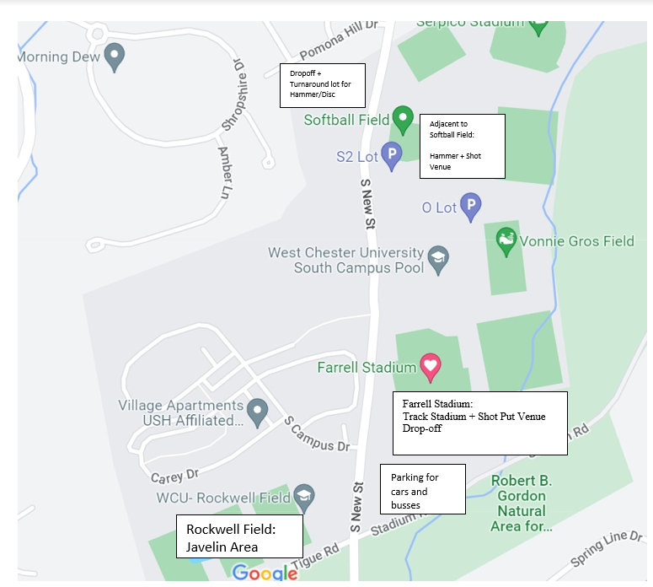

WCU Golden Ram Invitational
Saturday, April 9th, 2022
An approximate time schedule will be sent out after entries are in.
Time schedule is TENATIVE and SUBJECT TO CHANGE
PLEASE USE ATTACHED MAP TO PLAN
Throws FIELD EVENT SCHEDULE
9:30 M Javelin (Rockwell Field)
Followed by W Javelin (Rockwell Field)
9:30 M Shot (Farrell Stadium)
Followed by W Shot Put(not before W HT finish) (Farrell Stadium)
9:30 AM W Discus (WCU Throwing Facility)
(followed by) W Hammer (WCU Throwing Facility)
(followed by) M Discus (not before M JT & M SP finish) (WCU Throwing Facility)
(followed by) M Hammer (WCU Throwing Facility)
Jumps Field Event Schedule (Farrell Stadium)
10:00 AM W Pole Vault
Followed by M Pole Vault
W High Jump
Followed by M High Jump
10:00AM M Long Jump (Pit 1)
Followed by M Triple Jump (Pit 1)
W Long Jump (Pit 2)
Followed by W Triple Jump (Pit 2)
TRACK EVENT SCHEDULE (Farrell Stadium)
9:30AM W Steeplechase
M Steeplechase
10:15 AM W 4X100m Relay
M 4X100m Relay
W 1500m Run
M 1500m Run
W 100m Hurdles
M 110m Hurdles
W 400m Dash
M 400m Dash
W 100m Dash
M 100m Dash
W 800m Run
M 800m Run
W 400m Hurdles
M 400m Hurdles
W 200m Dash
M 200m Dash
W 5000m Run
M 5000m Run
W 4X400m Relay
M 4X400m Relay

